Student Details
Student Name: BENSON MUSAU
Admission Number: BSCCS/2023/51379
Course/Class: COMPUTER SCIENCE
Unit Code: BIT4138
Unit Name: Advanced Cryptography
Lecturer Name: NYORO MICHAEL
Semester/Academic Year: 2026
Project Details

Project Title: Advanced cryptographic decryption and encryption System

Selected Technologies: Python

GitHub Link
https://github.com/benmusau/BIT4138AdvancedCryptography.git

Contents
Student Details 1
Week 1: Cryptography Environment Setup 5
Figure 1: Installation of VS Code 5
Figure 2: Installation of PYTHON 6
Figure 3: Installation of Cryptography Libraries 7
Figure 4: OpenSSL Installation Test 8
Figure 5: Local Encryption Script Execution 9
Figure 6: GitHub Repository Initialization 10
REFLECTION 10
Week 2: Classical Cryptography and Cipher Design 11
Figure 8: Vigenère Cipher Encryption Process 12
Figure 9: Encryption and Decryption Output 12
Figure 10: User Input Validation Interface 13
Figure 11: Cipher Testing Results 13
REFLECTION 14
Week 3: Stream Ciphers and Randomness Testing 15
Figure 12: LFSR Generator Implementation 15
Figure 13: Pseudorandom Sequence Output 16
Figure 14: Statistical Randomness Testing 16
Figure 15: RC4 Stream Cipher Simulation 17
Figure 16: Encryption Performance Results 17
Reflection 18
Week 4: Block Cipher Design and AES 19
Figure 17: AES Encryption Script 19
Figure 18: Key Generation Process 19
Figure 19: File Encryption Demonstration 19
Figure 20: Decryption Results 20
Figure 21: AES Performance Testing 20
REFLECTION 20
Week 5: Public Key Cryptography (RSA) 21
Figure 22: RSA Key Pair Generation 21
Figure 23: Public Key Encryption Process 21
Figure 24: Private Key Decryption Results 21
Figure 25: Secure Message Transmission 21
Figure 26: RSA Testing and Validation 22
REFLECTION 22
Week 6: Hashing and Password Security 23
Figure 27: SHA-256 Hash Generation 23
Figure 28: Password Hashing System 23
Figure 29: Login Authentication Workflow 24
Figure 30: Hash Verification Results 24
Figure 31: Password Security Testing 24
Reflection 25
Week 7: Digital Signatures and Certificates 26
Figure 32: Digital Signature Generation 26
Figure 33: Signature Verification Process 26
Figure 34: Certificate Creation Using OpenSSL 26
Figure 35: Secure Document Validation 27
Figure 36: Certificate Testing Results 27
Reflection 27
Week 8: Secure Communication Protocols 28
Figure 37: SSL/TLS Configuration 28
Figure 38: Secure HTTPS Communication Test 28
Figure 39: Wireshark Traffic Capture 29
Figure 40: Encrypted Data Transmission 29
Figure 41: Protocol Security Analysis 30
Reflection 30
Week 9: Cryptanalysis and Security Testing 31
Figure 42: Brute Force Attack Simulation 31
Figure 43: Password Cracking Demonstration 31
Figure 44: Weak Key Analysis 31
Figure 45: Cryptanalysis Workflow 31
Security Recommendations Report 32
Reflection 32

Week 1: Cryptography Environment Setup
Title: Installation and Configuration of Cryptography Development Environment

Figure 1: Installation of VS Code
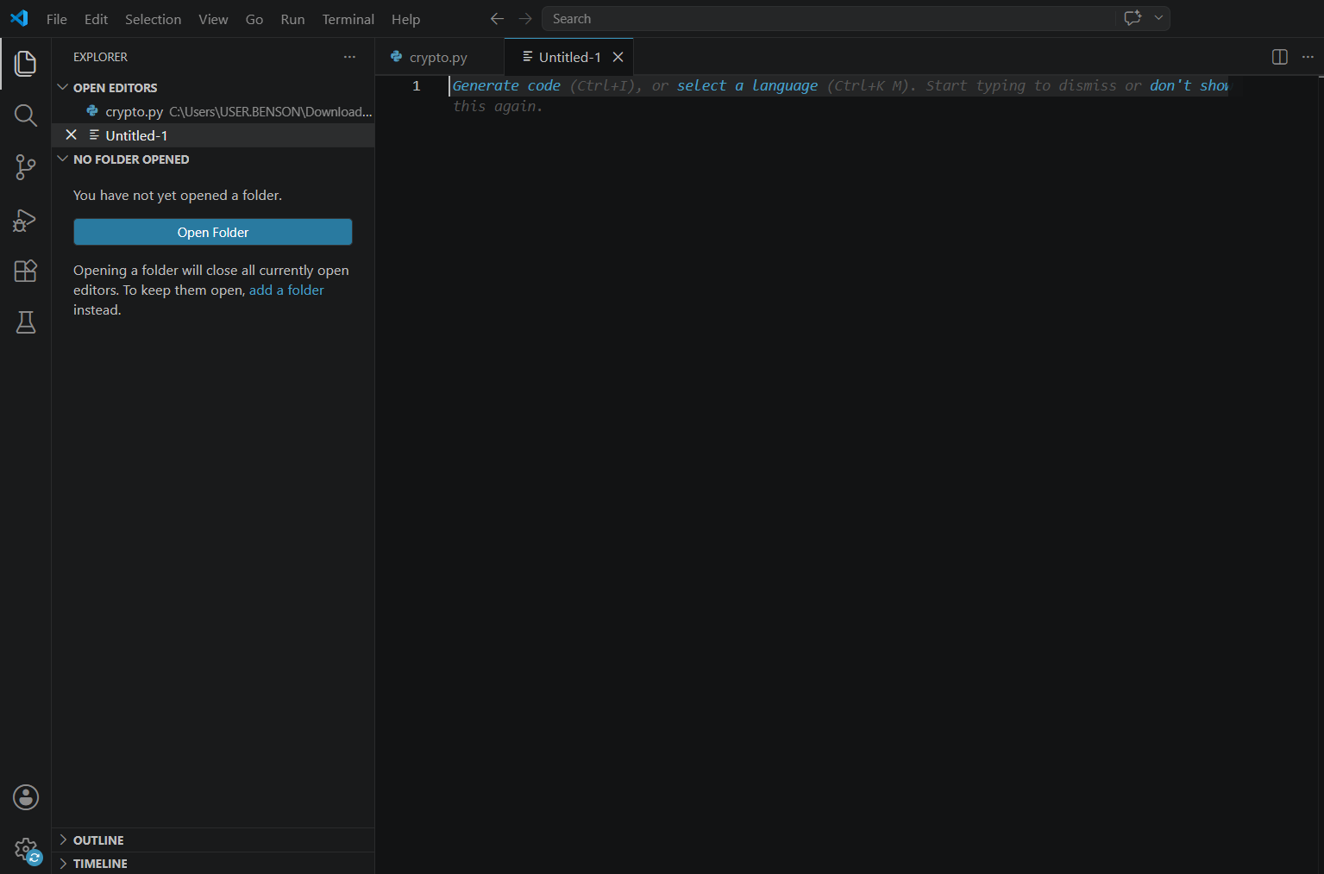

Figure 2: Installation of PYTHON
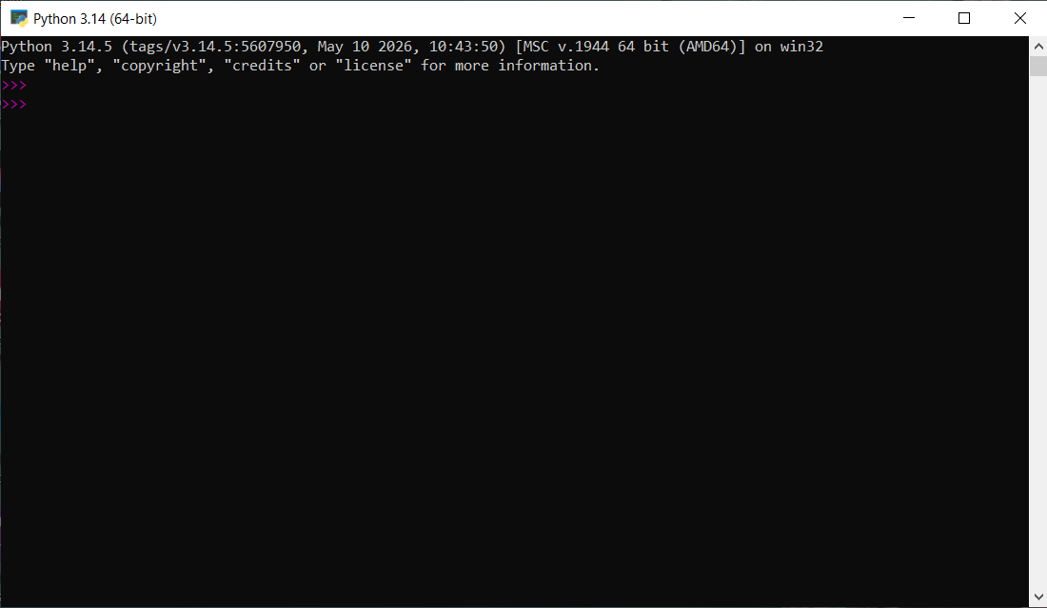

Figure 3: Installation of Cryptography Libraries
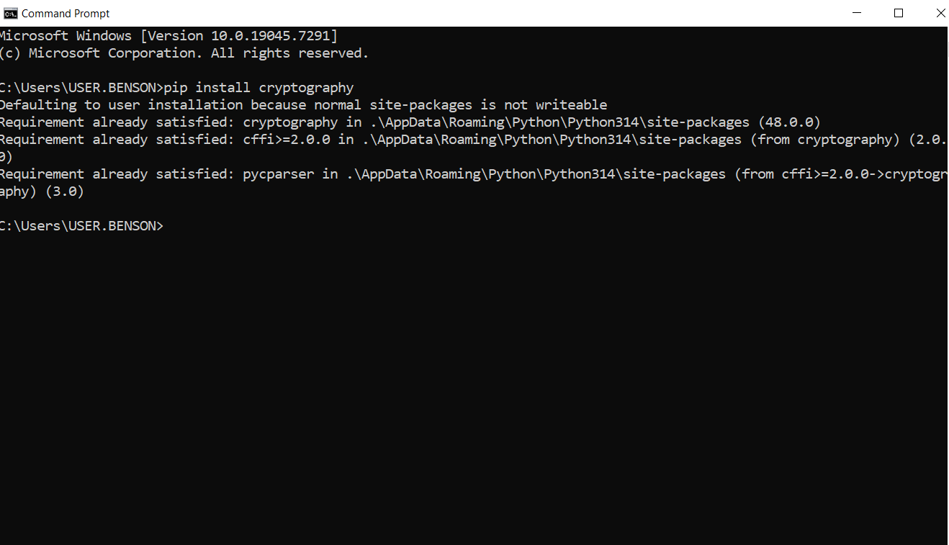

Figure 4: OpenSSL Installation Test
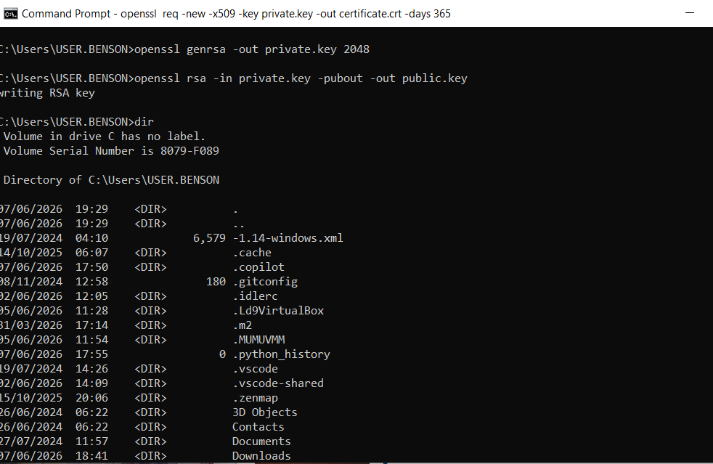

Figure 5: Local Encryption Script Execution
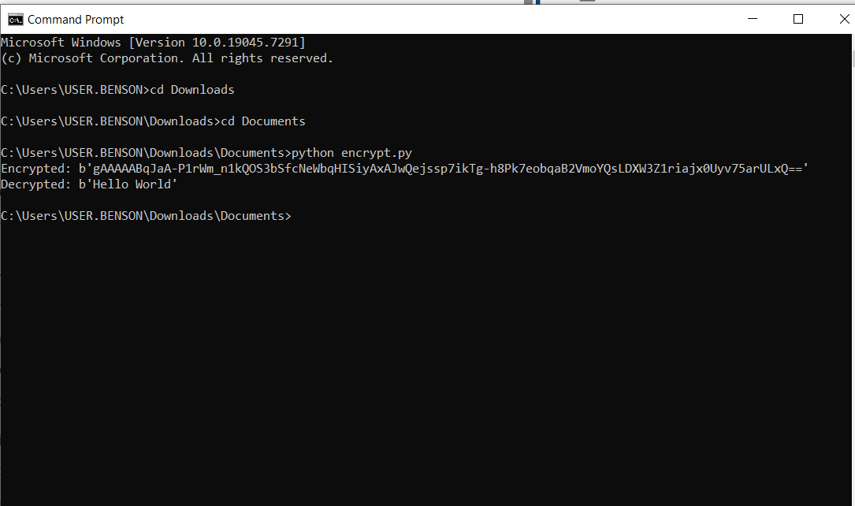

Figure 6: GitHub Repository Initialization
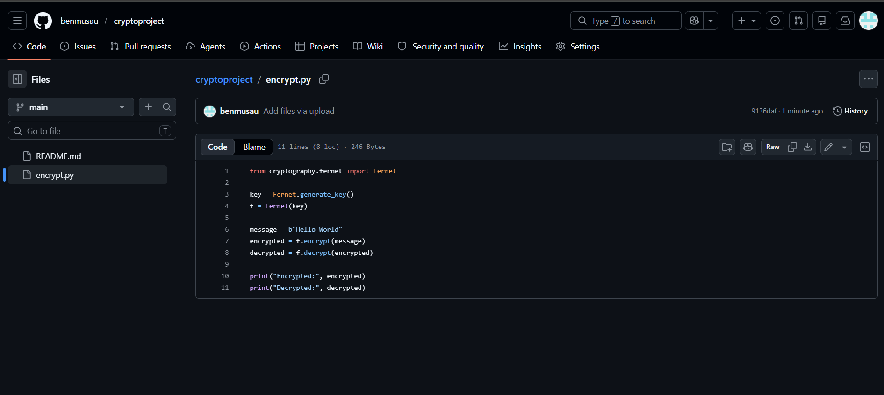

REFLECTION
I learned how to implement cryptographic techniques using Python and OpenSSL. Security tools configured include OpenSSL and a Python encryption script. The screenshots demonstrate successful setup, Fig 1: Installation of Python and VS Code, Fig 2: Installation of Cryptography Libraries, Fig 3: OpenSSL Installation Test fig 4: encryption execution, and fig 5: GitHub repository initialization. Challenges included installation errors and command usage.

Week 2: Classical Cryptography and Cipher Design
Title: Implementation of Classical Encryption Algorithms
Figure 7: Caesar Cipher Implementation
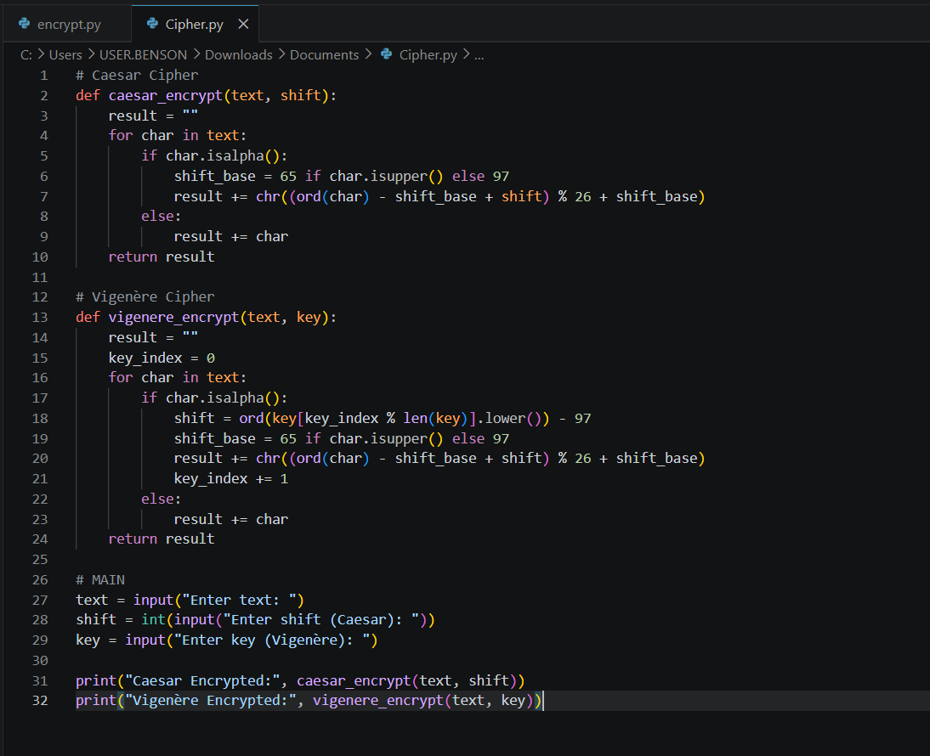

Figure 8: Vigenère Cipher Encryption Process
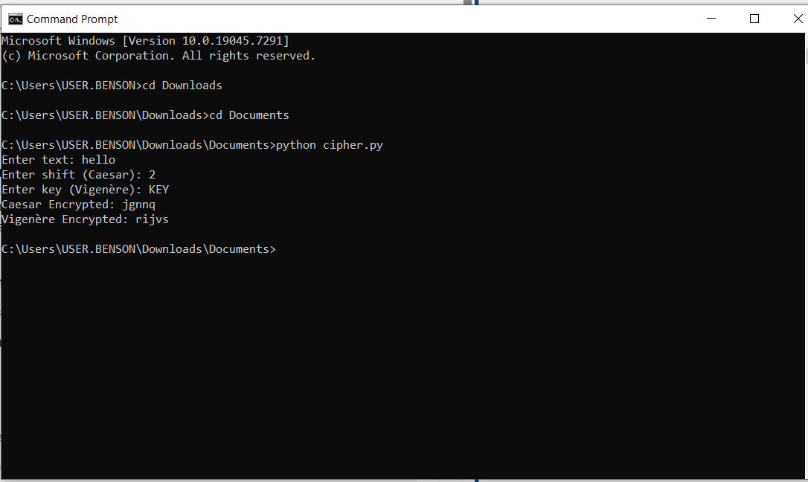

Figure 9: Encryption and Decryption Output
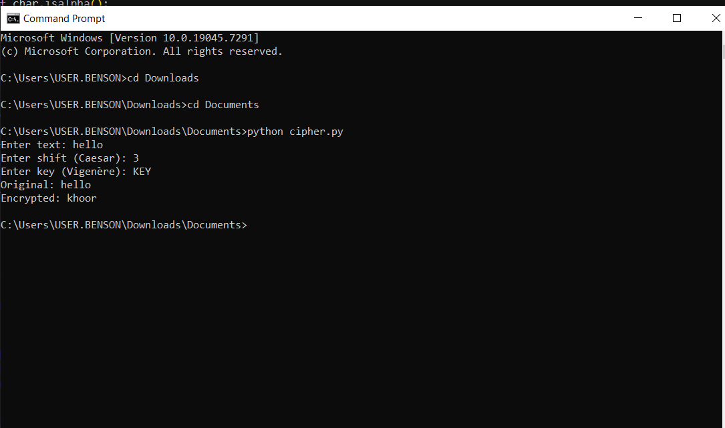

Figure 10: User Input Validation Interface
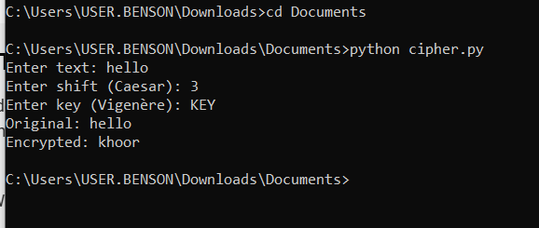

Figure 11: Cipher Testing Results
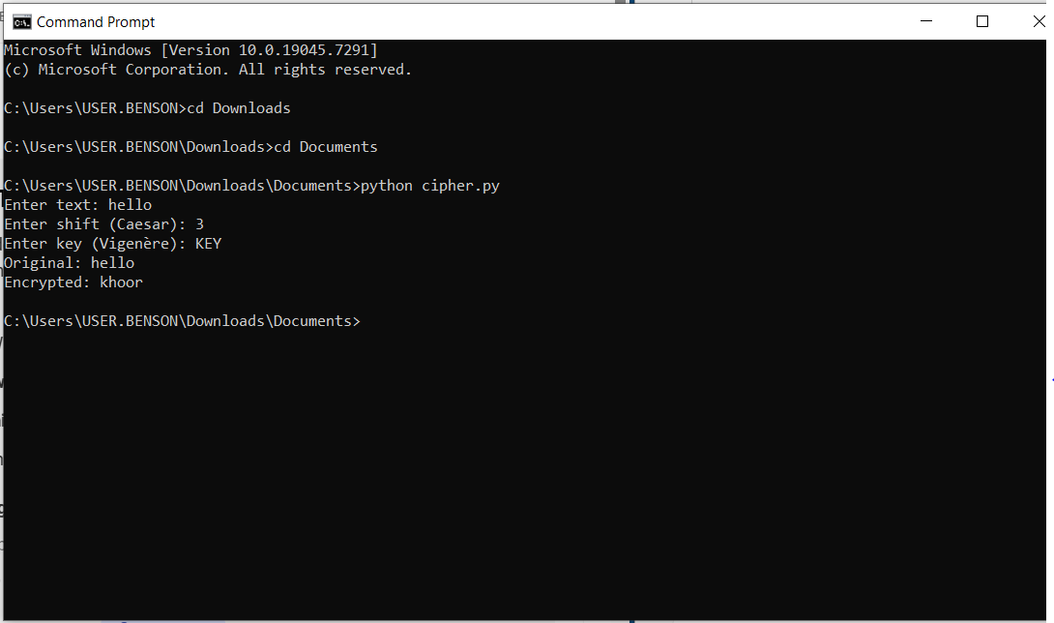

REFLECTION
The Vigenère Cipher implementation demonstrates how encryption algorithms transform plaintext into secure ciphertext. It shows the importance of keys in strengthening security and the overall encryption workflow. Weaknesses include simple ciphers being vulnerable to attacks, highlighting the need for stronger cryptographic methods like Vigenère.

Week 3: Stream Ciphers and Randomness Testing
Title: Implementation of Stream Cipher Systems and Random Sequence Analysis

Figure 12: LFSR Generator Implementation
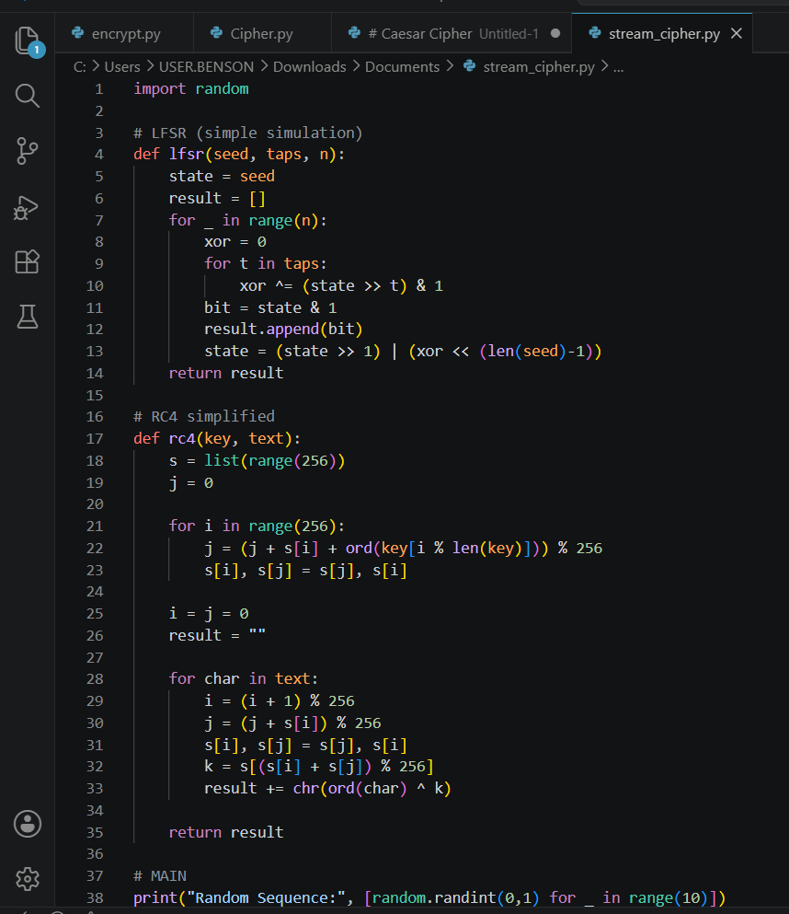

Figure 13: Pseudorandom Sequence Output

Figure 14: Statistical Randomness Testing
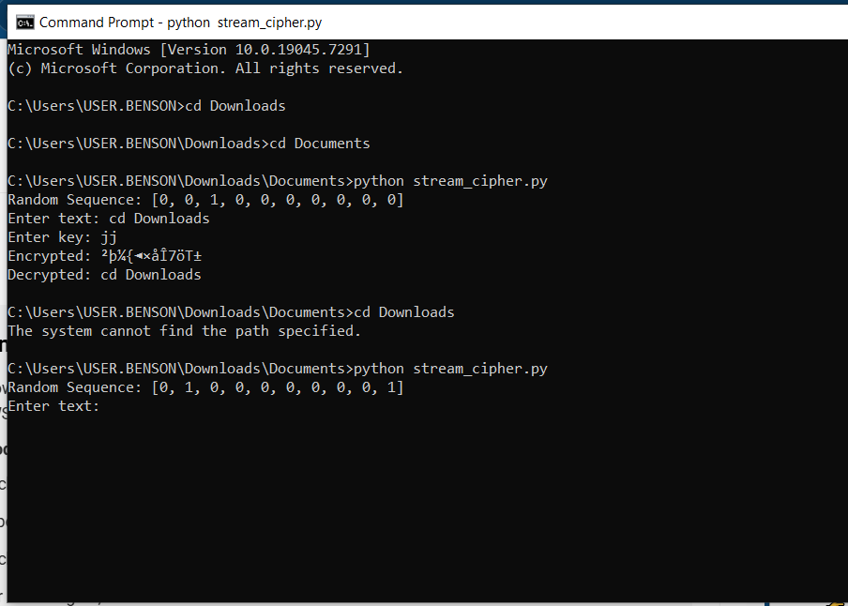

Figure 15: RC4 Stream Cipher Simulation
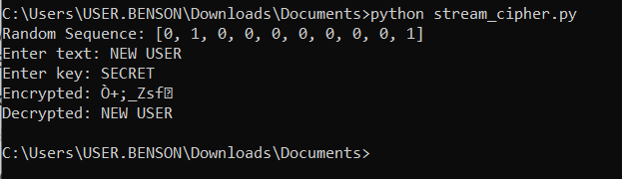

Figure 16: Encryption Performance Results


Reflection
This project demonstrated the importance of randomness in cryptography and how stream ciphers like RC4 encrypt data bit-by-bit using a key. Statistical testing showed variability in generated sequences, emphasizing the role of pseudorandom generation in ensuring secure and unpredictable encryption.”

Week 4: Block Cipher Design and AES
Title: Advanced Encryption Standard (AES) and Block Cipher Operations

Figure 17: AES Encryption Script
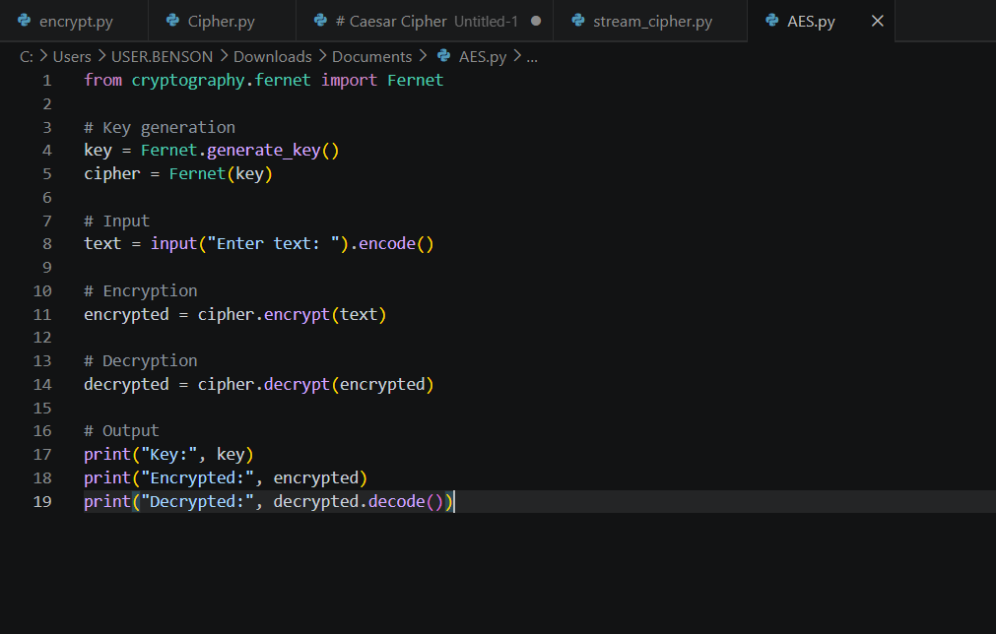

Figure 18: Key Generation Process
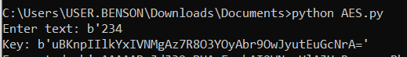

Figure 19: File Encryption Demonstration

Figure 20: Decryption Results

Figure 21: AES Performance Testing
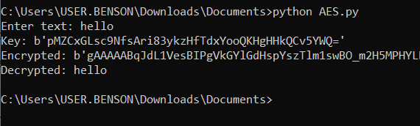

REFLECTION
This AES workflow demonstrated secure encryption and decryption using symmetric keys. Key security is essential to protect data from unauthorized access. This process involved converting plaintext to ciphertext and back. Challenges included installation issues and understanding command usage.

Week 5: Public Key Cryptography (RSA)
Title: Implementation of RSA Encryption and Key Management

Figure 22: RSA Key Pair Generation
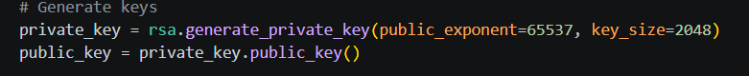

Figure 23: Public Key Encryption Process
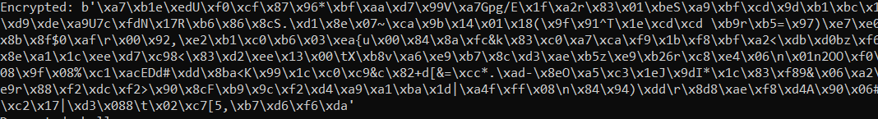

Figure 24: Private Key Decryption Results
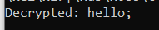

Figure 25: Secure Message Transmission
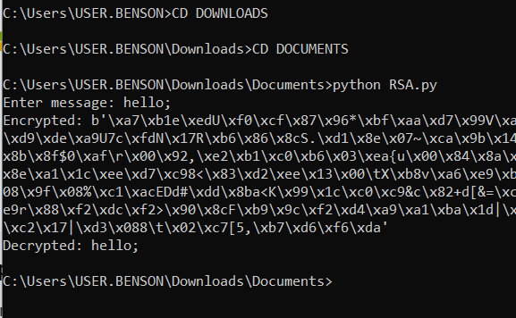

Figure 26: RSA Testing and Validation
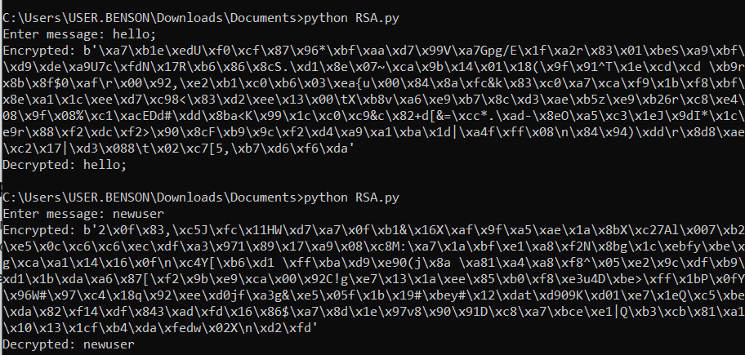

REFLECTION
It showed how asymmetric encryption differs from symmetric by using separate public and private keys. RSA improves security through key separation. Testing confirmed secure encryption with the public key and accurate decryption with the private key, demonstrating its effectiveness for secure communication.

Week 6: Hashing and Password Security
Title
Implementation of Secure Hash Functions and Authentication

Figure 27: SHA-256 Hash Generation
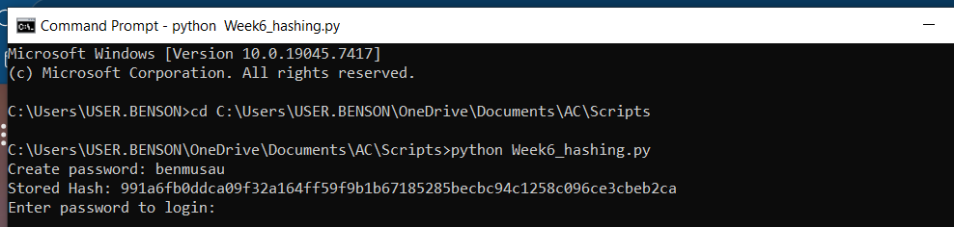

Figure 28: Password Hashing System
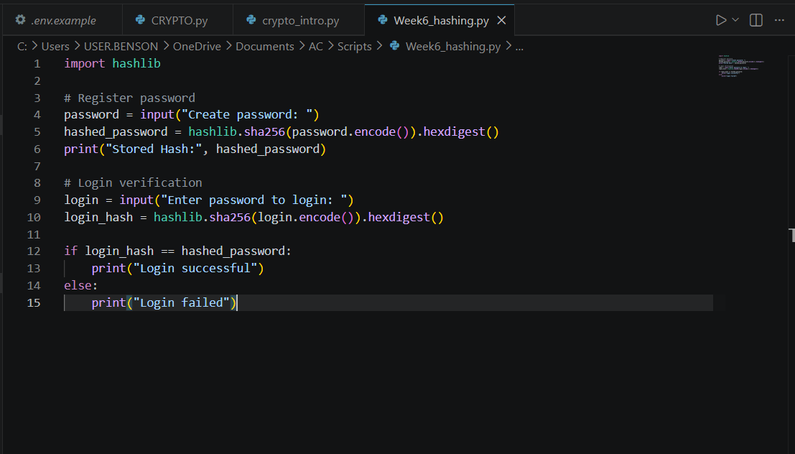

Figure 29: Login Authentication Workflow
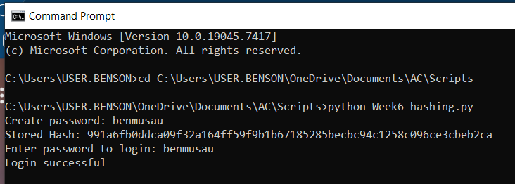

Figure 30: Hash Verification Results
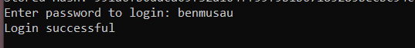

Figure 31: Password Security Testing
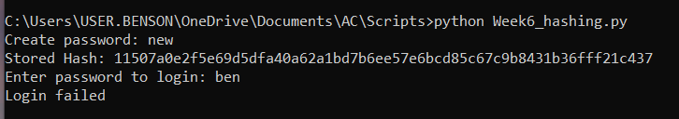

Reflection
Hashing is irreversible because it produces fixed values that cannot reveal the original password. Password security protects user credentials. The authentication workflow compares stored and entered hashes. Security was improved by applying SHA-256 hashing instead of saving passwords in plain text

Week 7: Digital Signatures and Certificates
Title: Digital Signature Implementation and Certificate Management

Figure 32: Digital Signature Generation
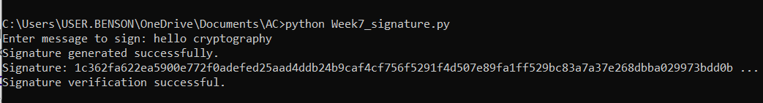

Figure 33: Signature Verification Process
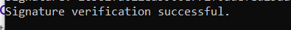

Figure 34: Certificate Creation Using OpenSSL
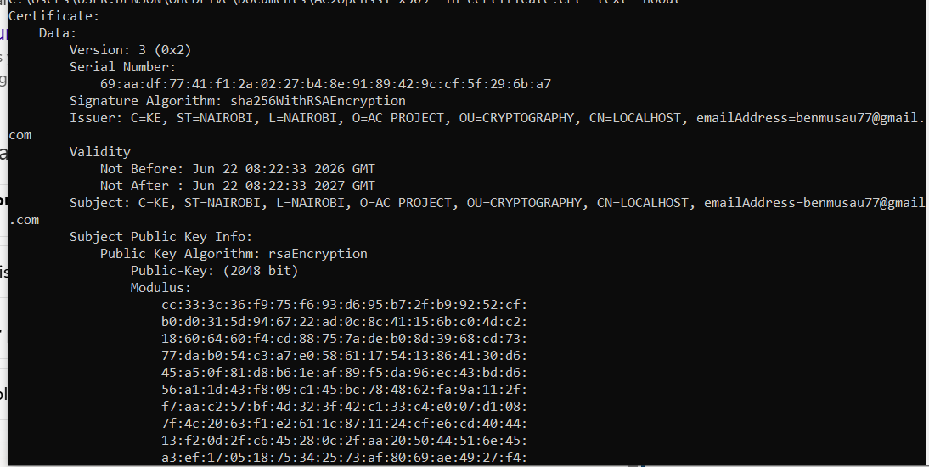

Figure 35: Secure Document Validation
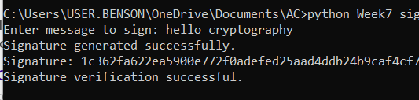

Figure 36: Certificate Testing Results


Reflection
This demonstrates how digital signatures provide authenticity and integrity using private and public keys. Certificate creation with OpenSSL supported trusted verification. The workflow showed signing, verification, and certificate testing, improving understanding of secure document validation and certificate management in practical cryptographic systems.

Week 8: Secure Communication Protocols
Title: Implementation and Analysis of Secure Communication Systems

Figure 37: SSL/TLS Configuration

Figure 38: Secure HTTPS Communication Test
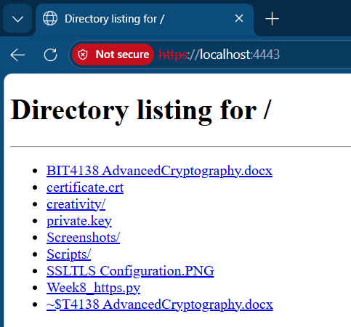

Figure 39: Wireshark Traffic Capture
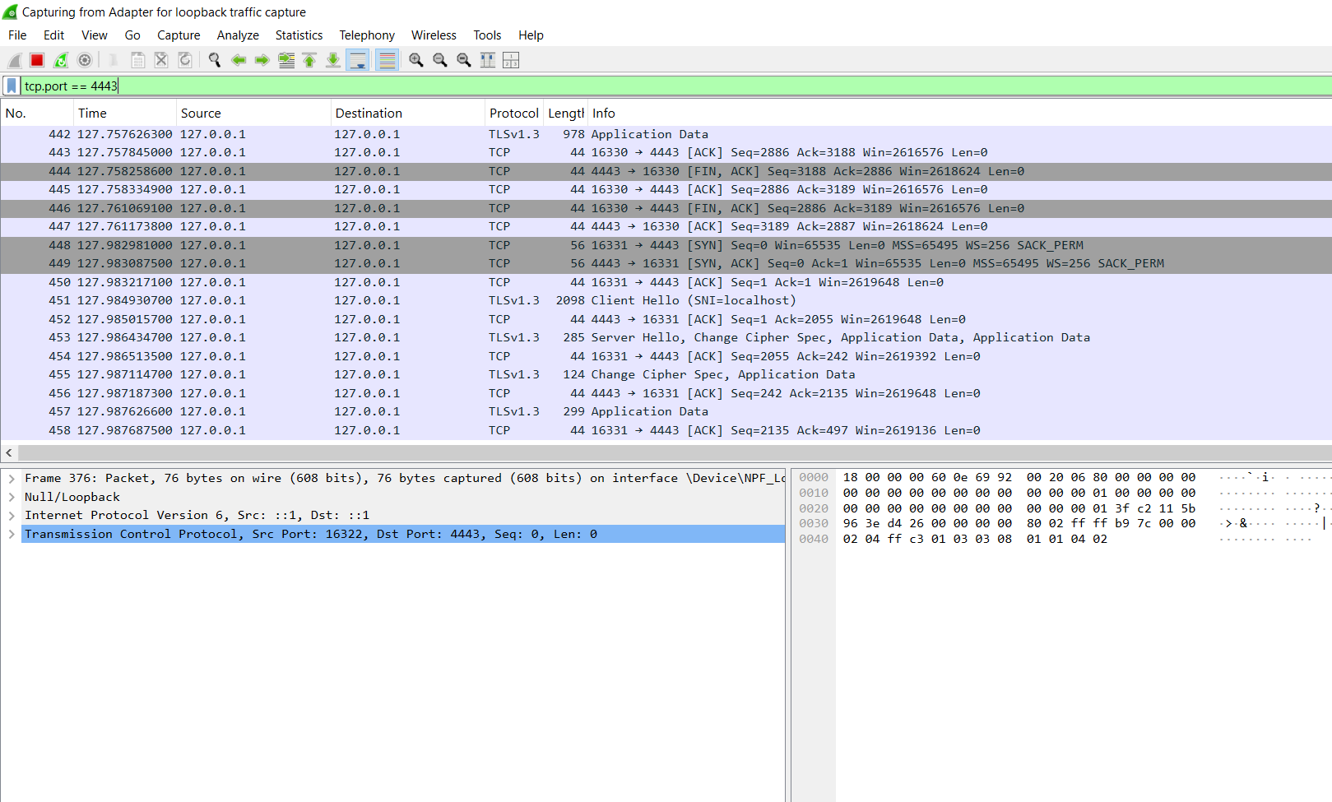

Figure 40: Encrypted Data Transmission


Figure 41: Protocol Security Analysis
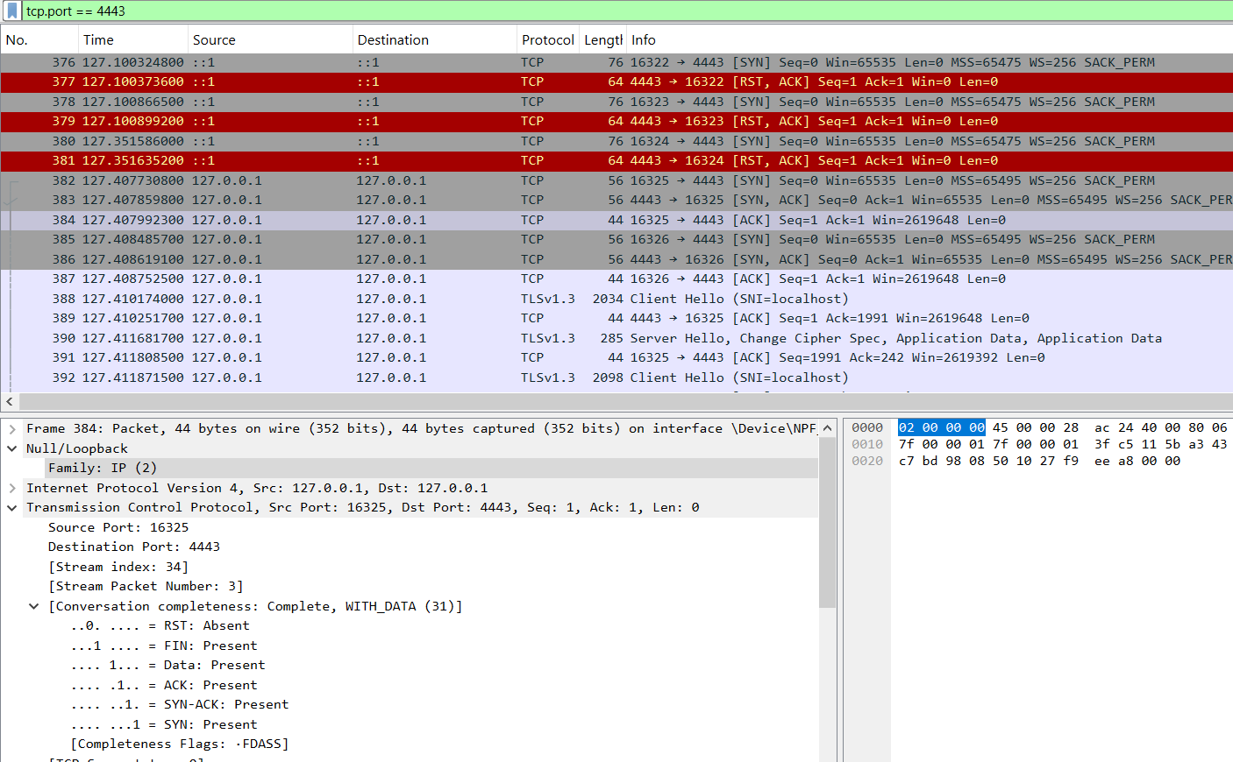

Reflection
This project shows secure communication works by encrypting data between a client and server. SSL/TLS protected the connection through authentication and encryption. Packet analysis revealed TLS handshakes and encrypted application data. A key challenge was capturing localhost traffic correctly and selecting the proper Wireshark interface

Week 9: Cryptanalysis and Security Testing
Title: Cryptographic Attack Simulation and Security Evaluation

Figure 42: Brute Force Attack Simulation
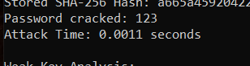

Figure 43: Password Cracking Demonstration
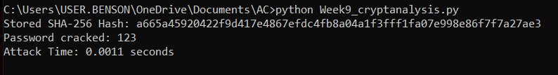

Figure 44: Weak Key Analysis
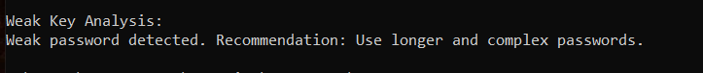

Figure 45: Cryptanalysis Workflow
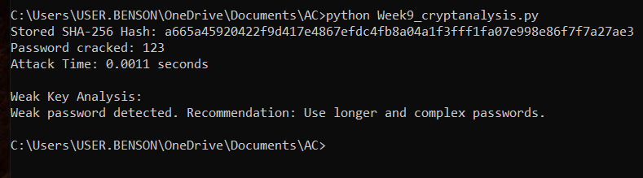

Security Recommendations Report
- Avoid common passwords like 123, admin, or password.
- Apply strong hashing methods.
- Limit login attempts.
- Use long passwords.
- Use multi-factor authentication.
- Use uppercase, lowercase, numbers, and symbols

Reflection
This project revealed that weak passwords are vulnerable to brute force attacks. Ethical testing was performed using a controlled lab password. The workflow demonstrated hashing, cracking simulation, and weak key analysis. Security improvements include using complex passwords, stronger hashing, login attempt limits, and multi-factor authentication.

